Pandas Documentation

- Pandas Installation
pip install pandas

- Import Pandas
import pandas as pd

- DataTypes
- Series
- DataFrames

- Series
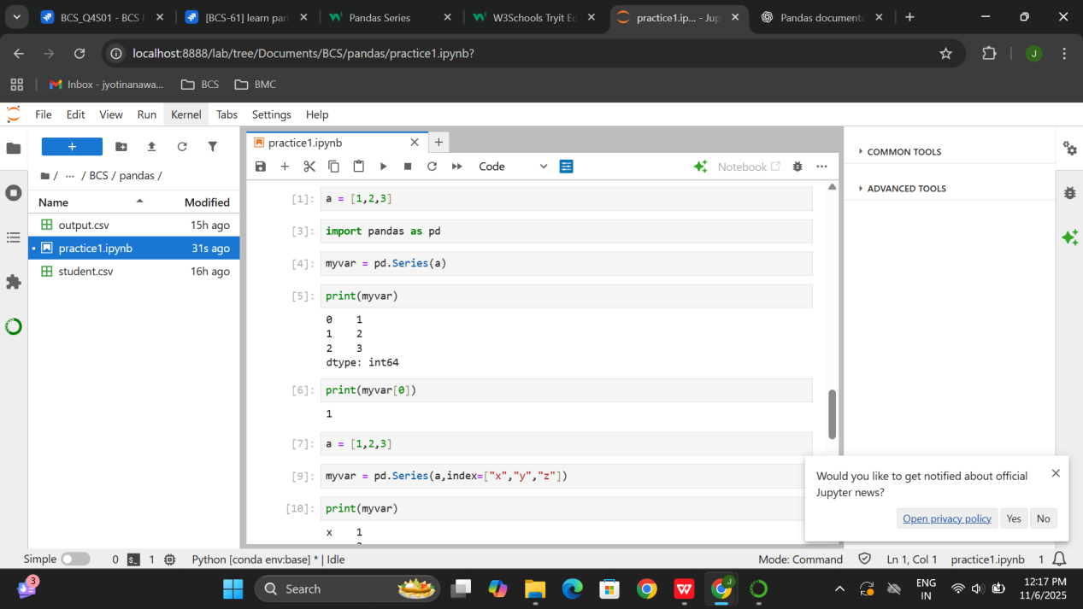
- Import Pandas as pd as a alias to make it easy for further use.
- Convert variable to series format.
- Print the data and the output has auto-generated indexing by default.
- In second example we can provide customized indexing.
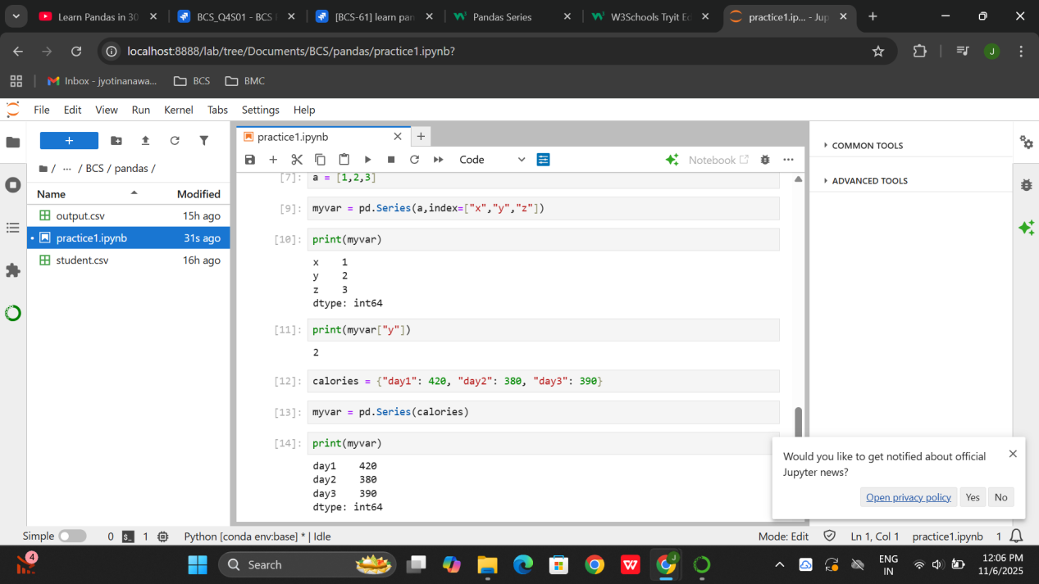
- Print the output and try to call the data with the help of index
- Pass key value pair where key becomes the index.

2.Dataframes

- Using pd.DataFrame()
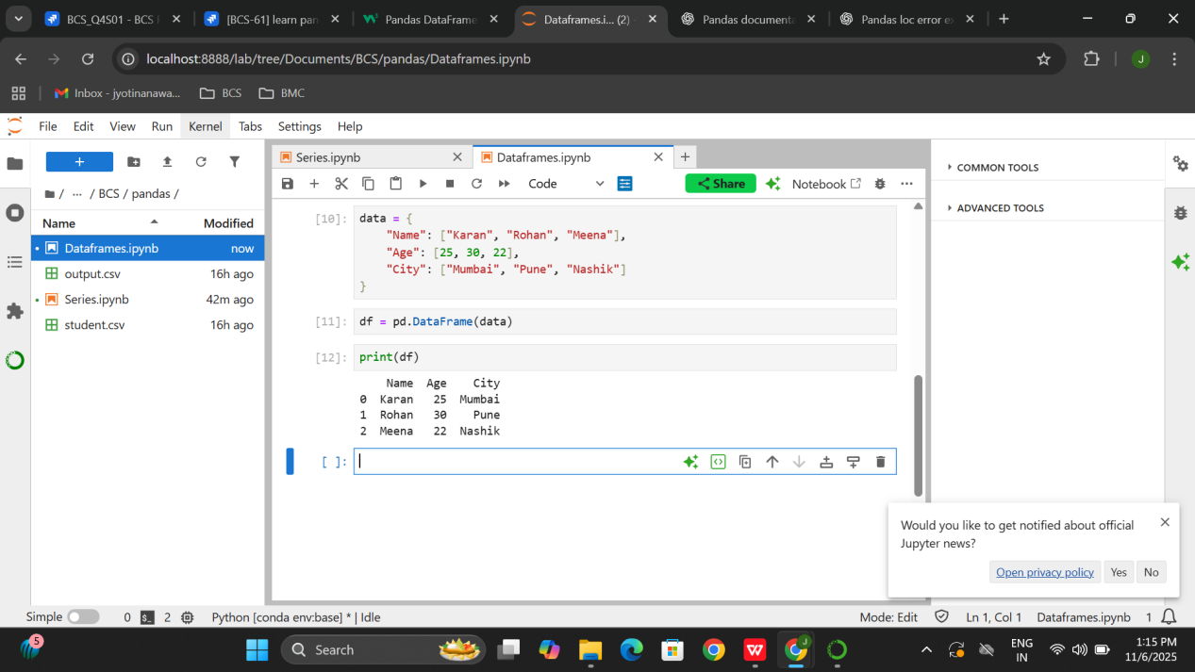
- Using pd.read_csv()
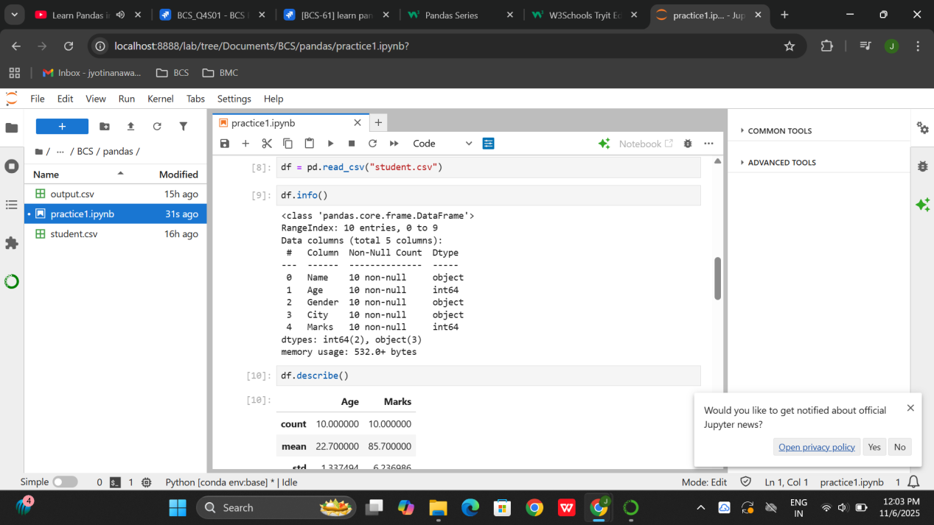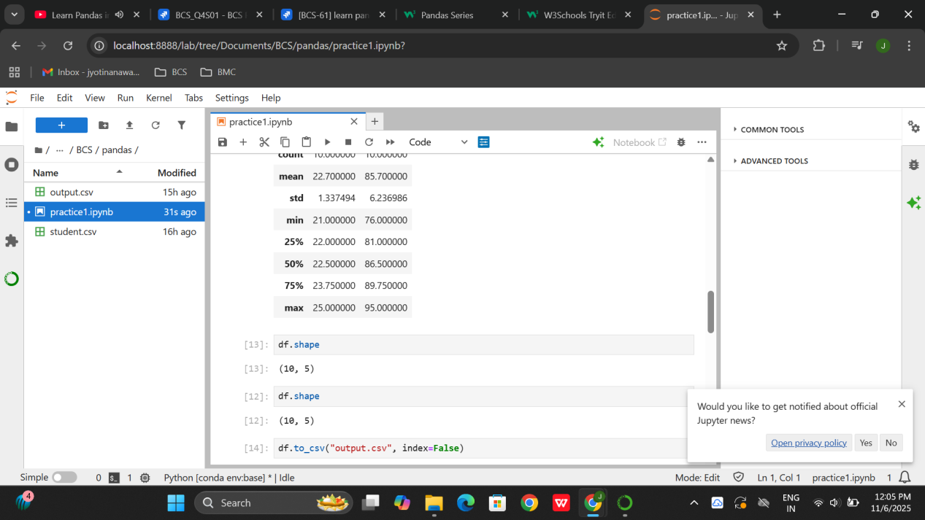

4.Combine Data
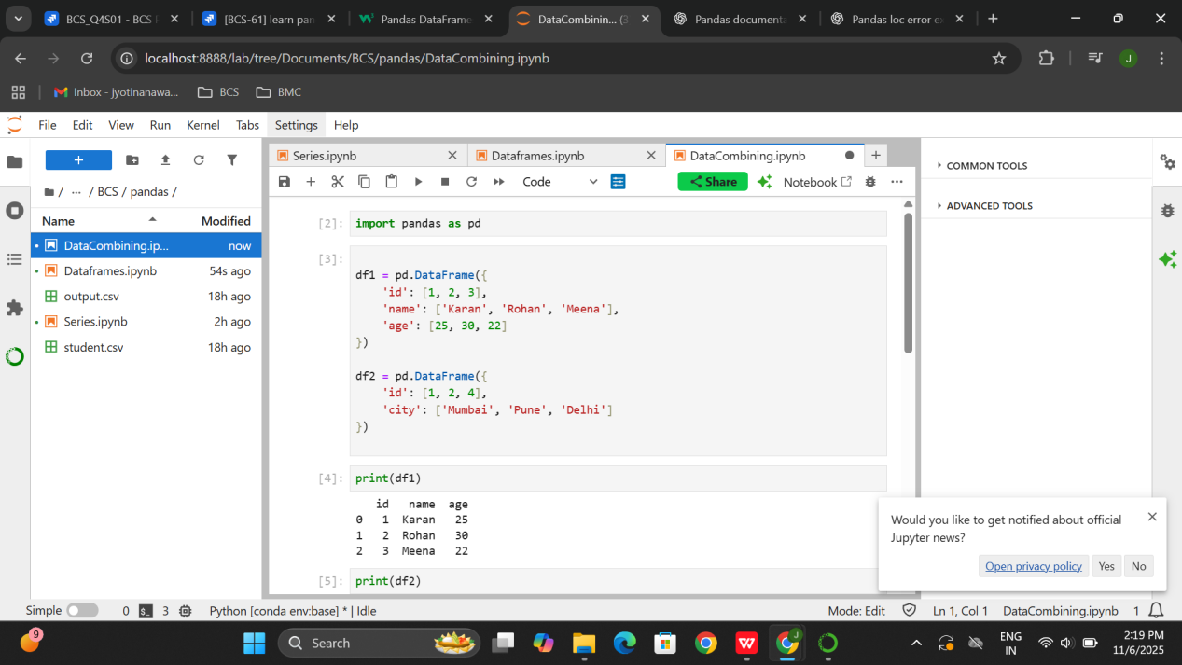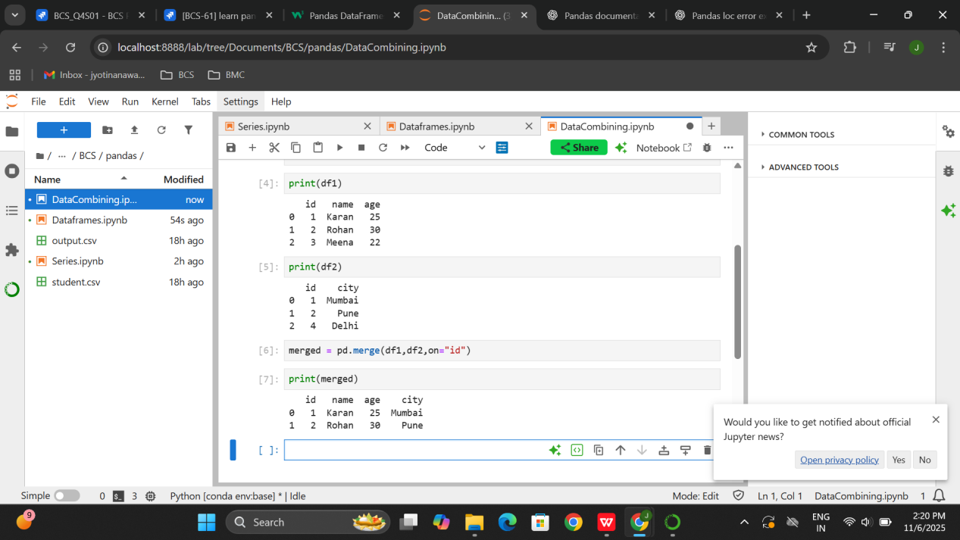
- Merge the two dataframes on the basis of ID

5.Combining Data
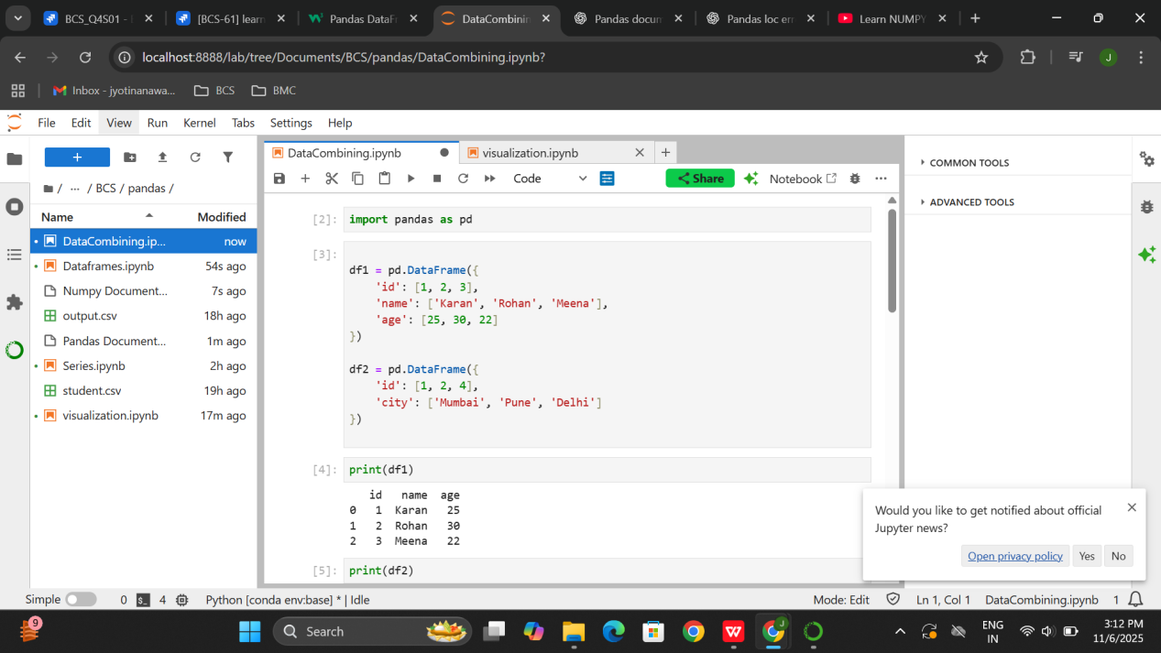
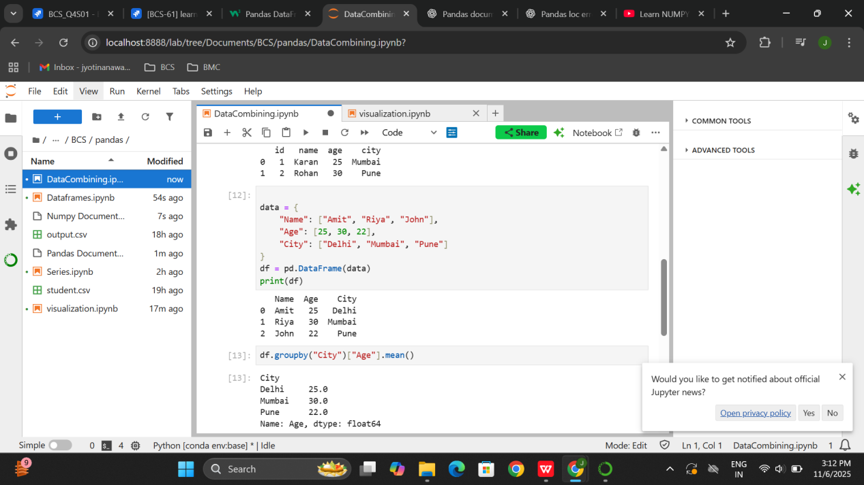
- The mean of the age and then sort them according to City in ascending.

5.Visualization
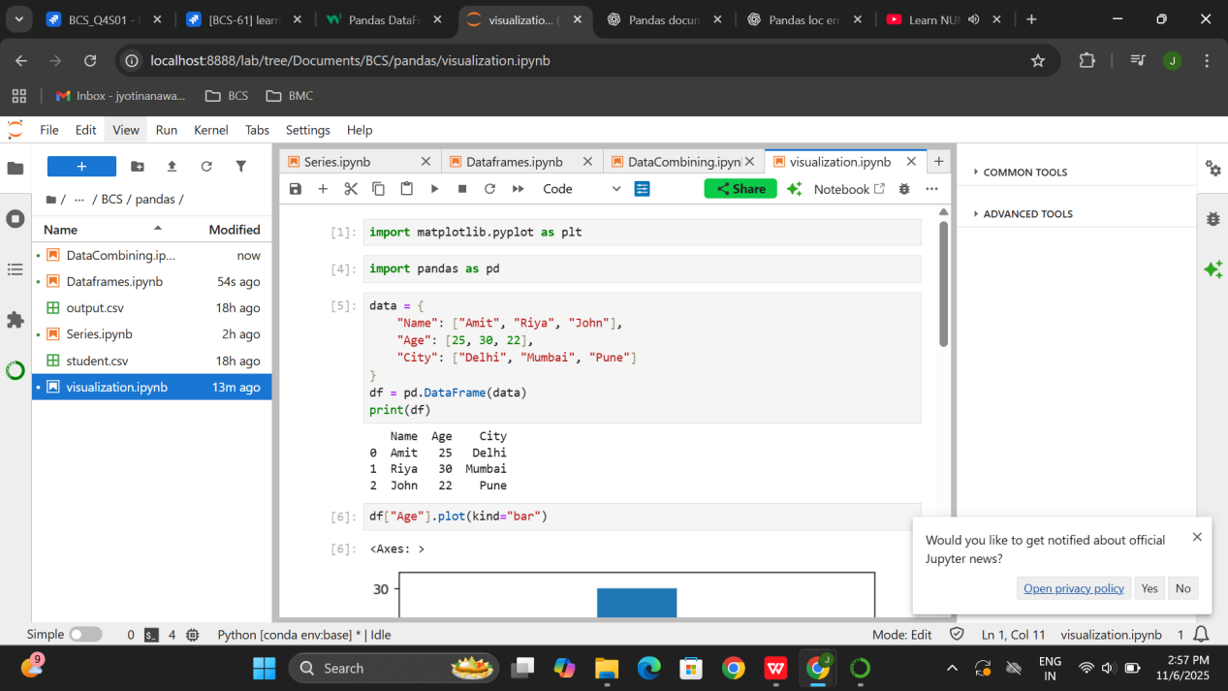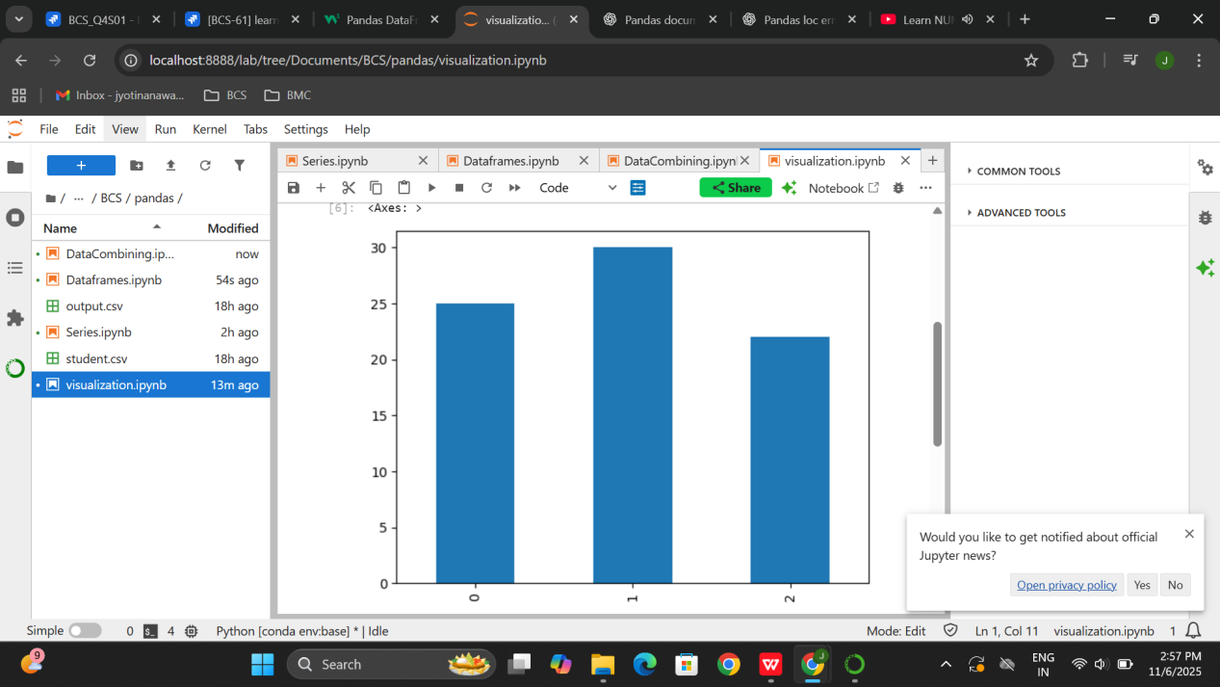

GeeksforGeeks

- Pandas Dataframe Index
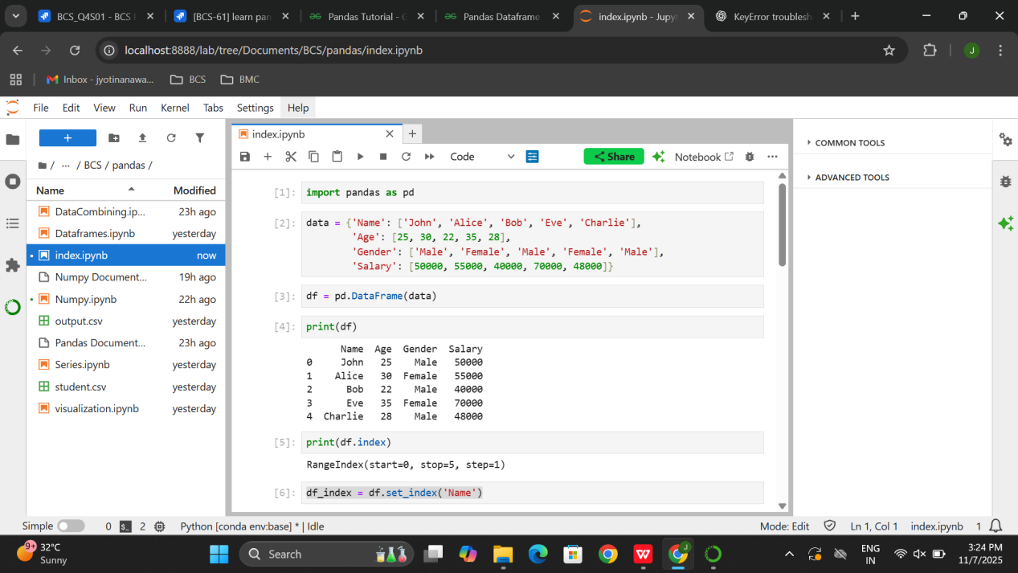
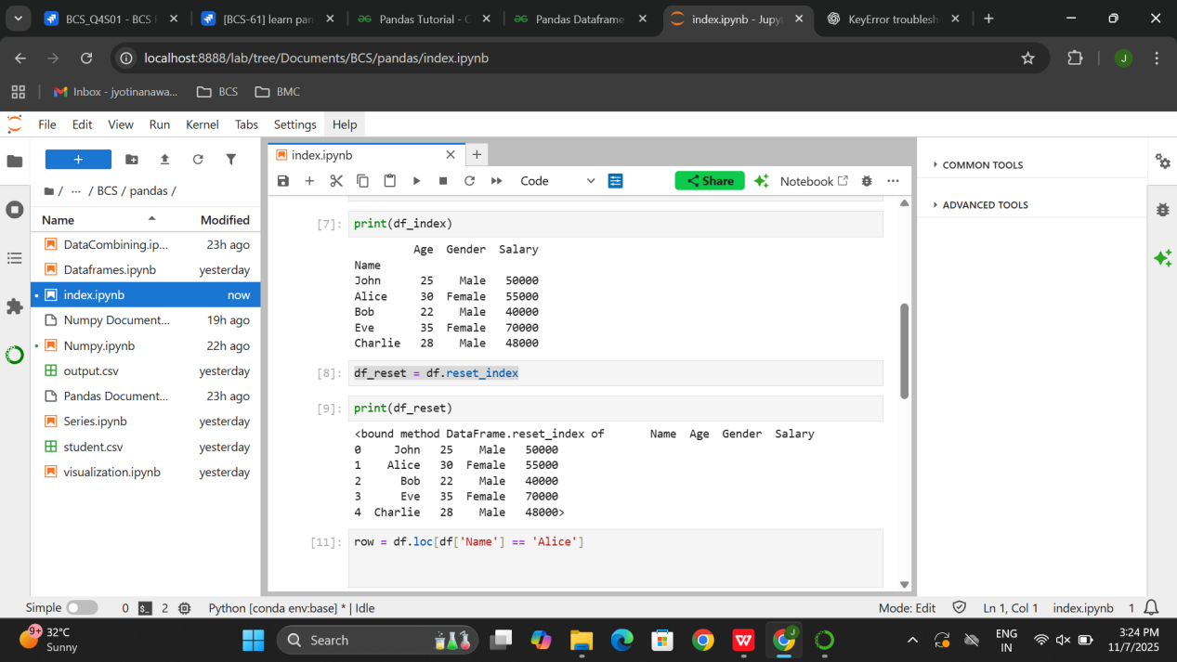
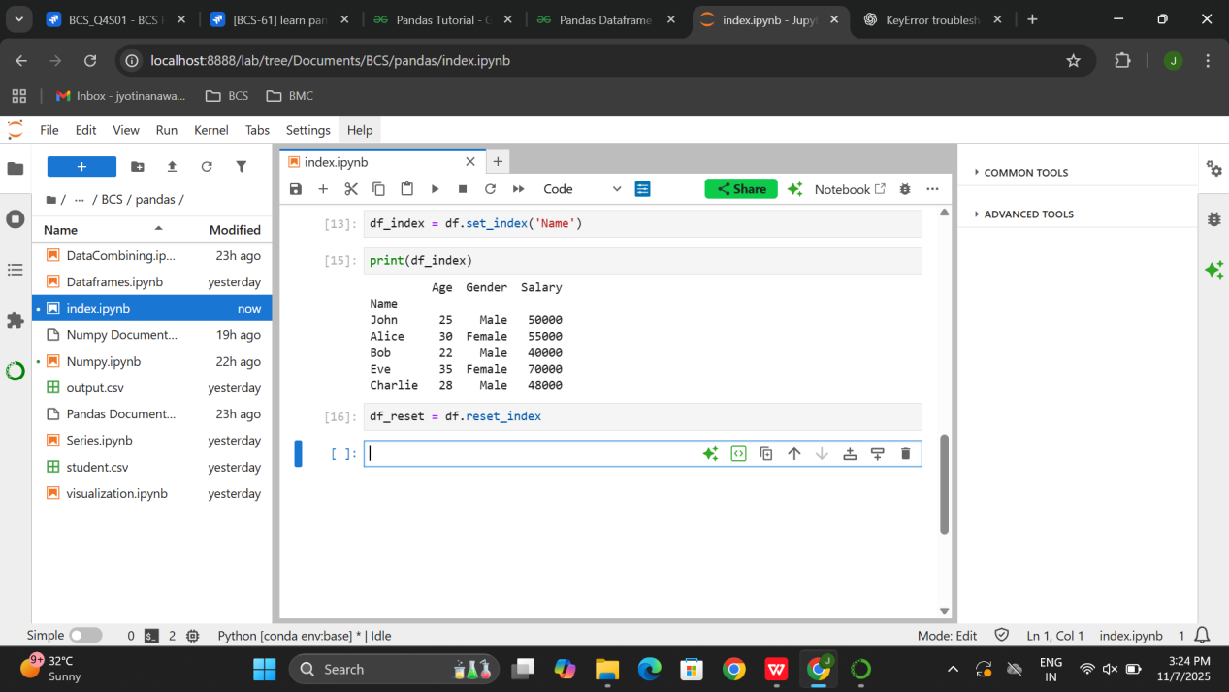

- Pandas Access Dataframe
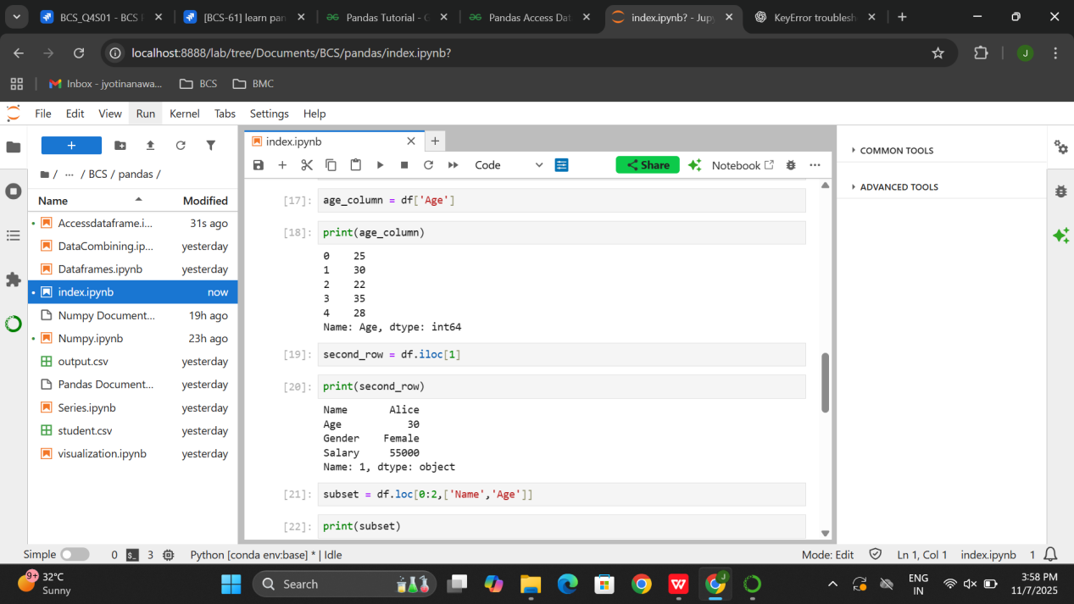
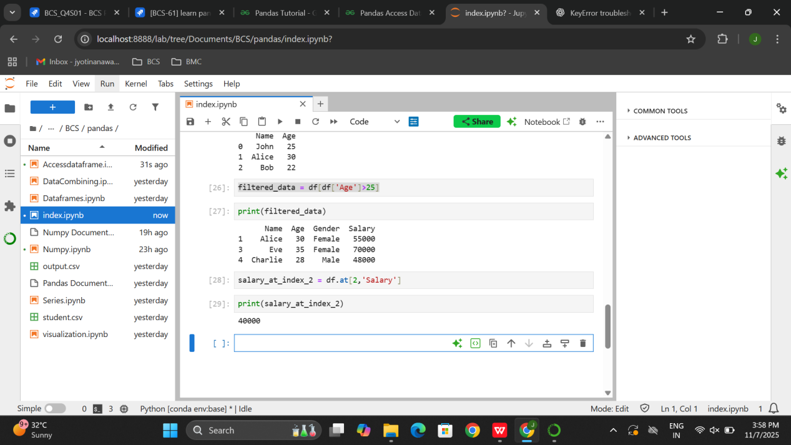
3.

